I cannot find that file!

Introduction

Have you ever ‘lost’ a file or folder on your computer? I have! Many times!

You create a document, save it, print it and then forget where you saved it to!

Well, here are some ideas you can try out to find those elusive documents.

Recent Items

If you have recently used the file or document in the last few days or even week it may still be listed in your ‘Recent Items’ menu. How to locate that?

Select Recent Items from the Apple menu on the left hand side of your Apple computer’s display. See the example below.

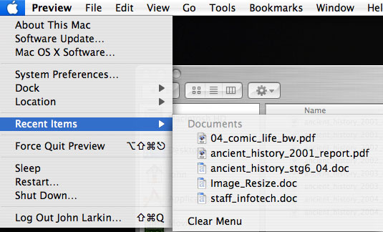

As you can see in the example above there are five documents available in the Recent Items menu. Is the document that you are looking for listed in that menu? If so select that item and it should open.

If the document or file is not listed there then you may like to try the other methods outlined later in this document.

Fine tuning the Recent Items

You can fine tune the Recent Items menu by making changes in the System Preferences application on your Apple computer. How can you achieve that?

Select the System Preferences menu item from the Apple menu. See the illustration below.

The application will open and the following window will appear.

Click on the Appearance button situated on the upper left hand corner of the application window. The following window will appear.

Towards the bottom of the window you will see the section listed “Number of Recent Items”. You can choose how many Applications, Documents and Servers are appear in the Recent Items menu. In the example above I have changed the desired listings to 5 applications, 10 documents and no servers. The results can be seen in the screen shot below.

You will observe that five applications are listed in addition to the ten documents.

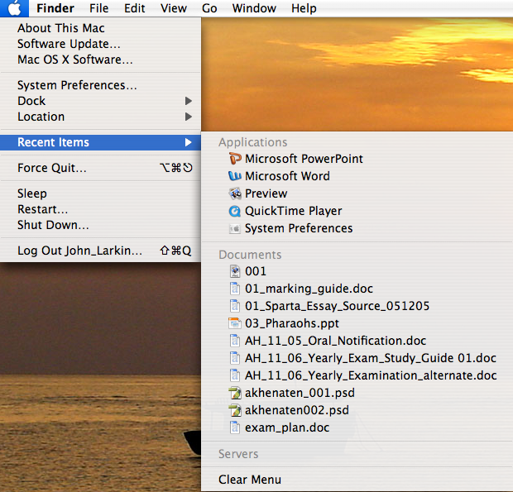
Find Files

What else can you try to locate a file or folder on your computer. You can select the Find… menu item from the File menu. See the example below.

The following window will appear.

Type the name of the file or even part of the name and documents and folders will begin appearing in the window below. You can even type a word that appears in the document itself it should appear in the window below.

You will note that there are four buttons located at the top of the window. You can use these to fine tune your search even further. Have a look at the screen shot below to get an idea or two about the capability of this tool.

A search for a doucment that contains the word assessment in the file name and was modified or changed in the last two weeks has been made using the buttons to fine tune the search. This can be a powerful tool.

Spotlight

Yet another tool that you can use is Spotlight. You can access Spotlight by selecting the small magnifying glass icon located in the top right hand corner of the Apple computer screen.

A search field will appear and all you need to do is type in the name of the file that you are seeking. You will see from th eexample below that a variety of files will be listed including email messages in Entourage and bookmarks in Safari, for example.

Typing Command ~ Space Bar will bring up the Spotlight menu as well.

Open Dialogue Box in applications

Another way to find files… you can type in a search for a document within an open dialogue box. If you select the “Open…” menu from the File menu in Microsoft Word you will see a window like the one below.

If you enter the name of the file in the search field your document will be located quickly. Look at the example below.

Select your document from the list and proceed with your work. This technique applies to all applications.

Organisation

When you have the time it is not a bad idea to organise your files. The window below is an example of what is possible. Naming and numbering conventions can be applied to your files and folders.

You can also colour code your documents and folders using the Color Label feature in the File menu.

